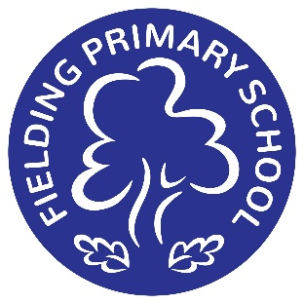 | Peter Dunmall BSc (Hons), PGCE, MAEd, NPQH  Head Teacher  Clare Haines BEd (Hons), PGDip, MAEd, NPQH  Deputy Head Teacher

05/05/2026

Boston Manor Workshops

Dear Parents/Carers,

On Thursday 25th June, pupils in Acorn, Leaf, and Oak classes will be participating in an ARP educational visit to Boston Manor Park for a series of nature-based workshops. The purpose of this trip is to support pupils’ EHCP outcomes—particularly social skills such as sharing and turn-taking—as well as their science learning across key areas: habitats (Oak), planting and seasonal changes (Leaf), and land animals (Acorn). Children will walk approximately one mile to the park and one mile back, with staff ensuring road safety rules are followed throughout the journey.
There is a cost of £10 per child for the trip which is available to pay via MCAS.

We will depart school at 9:45am and expect to return by approximately 2:15pm. Children should wear full school uniform, suitable footwear, and a coat appropriate for the weather. They will need to bring a healthy packed lunch and water, as we will be eating lunch in the park or in an indoor space if required. Please note that school-packed lunches will only be provided if you email the admin office at least five days before the trip. Please also ensure all medical information held by the school is up to date.

To support the smooth running of this trip, we kindly request the assistance of some parent volunteers – we will need support from 4 or 5 parent volunteers. If you are able to accompany us, please inform Mrs Trott. All volunteers will be required to sign a volunteer pack at the main office before the visit.

Thank you for your continued support.

Yours sincerely,

Ali Trott
ARP Lead and Oak Teacher

