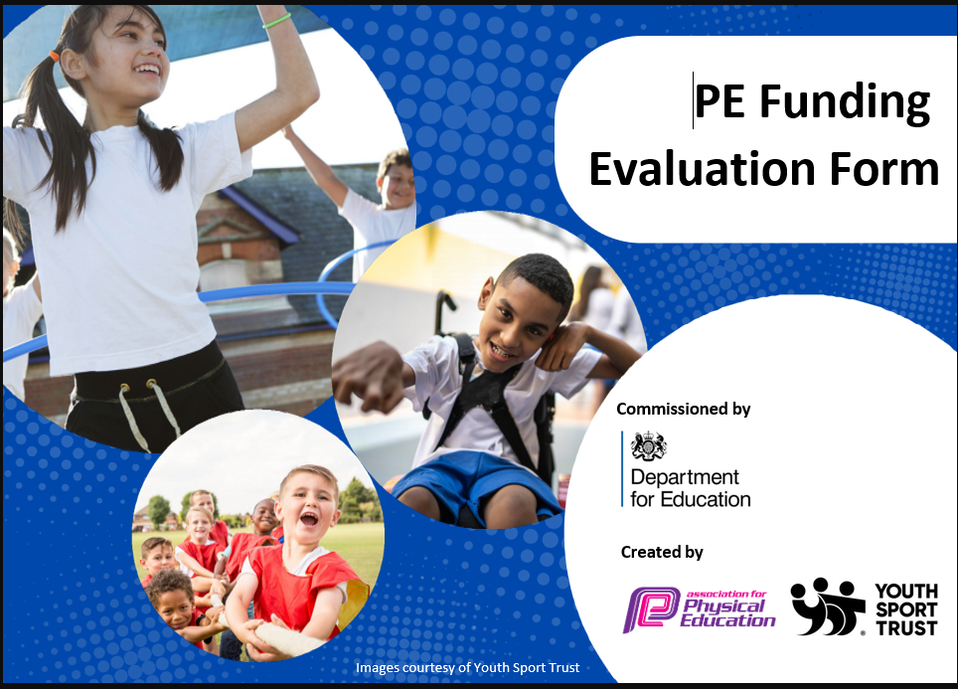

2025/26
Total amount carried over from 2023/24: | £0
Total amount of funding for 2024/ 25: | £23, 760

Review of last year’s spend and key achievements (2024/25)
Activity/ Action | Impact
Enrolled in the Featherstone School Sports Partnership Sports Offer and maintained the Platinum Award. The cost implications included the need to release PE staff to attend competitions, as well as the expense of purchasing the services provided by the organisers.  School Games Mark: Platinum  Success at competitions run by multiple agencies such as Featherstone, Middlesex Running Club, Ealing Girls Cup, London Youth Games | The gained access to a range of competitions, including performance and development events, SEND events, festivals, and virtual and hybrid competitions. Thus, enabling both boys and girls a chance to compete, develop key skills, build confidence, and stay active.  Fielding maintained the Platinum School Games Mark which highlighted the school's exceptional dedication to physical education and inclusive sports programs. By offering daily active minutes, diverse competitions, and leadership opportunities, the school fostered a culture of health and teamwork. These efforts not only improved physical fitness, but also promoted confidence, social skills, and a positive attitude toward physical activity among all pupils.  Success in these competitions boosted the children’s confidence, broke down gender barriers and highlighted their skills across a range of sports. Access to diverse competitions promoted inclusion for all pupils to achieve in sports irrespective of their ability.

Key Achievements 2025/ 26

Activity/ Action | Impact
Membership in Featherstone School Sports Partnership and Ealing Leagues (PE CPD and pupil competitions)  Training of wider school staff to support competition preparation  Regular celebration of sporting achievements in assemblies and on the school website  Introduction of non- traditional on the curriculum | This year, the quality of PE has continued to improve significantly across the school. Pupils have benefited from consistently high-quality PE lessons that are well planned, engaging, and progressive, ensuring the development of both skills and enjoyment of physical activity.  The PE team has developed into a confident, competent, and highly effective team of practitioners. Through continued professional development, collaboration, and shared best practice, staff now deliver PE with greater consistency and confidence, resulting in an improved teaching and learning experience for all. This has had a positive impact on pupil participation, behaviour, skill development and overall enthusiasm for PE and school sport.  Networking with local schools created new opportunities for many friendly inter- school competitions.  Pupils had access to a range of sporting competitions (festivals, leagues and one- off tournaments). This provided increased opportunities for inter-school competitions, whilst targeting key groups of pupils (elite, SEND and pupil premium).  Year 5/6- Mini Orange Tennis Champions  Year 5/6 Cross Country- =1st Place  Year 5/6 Tenpin Bowling- 3rd place  Year 5/6 Boys Football- PEAL Shield Runners up  Year 5/6 Girls Football- Ealing =3rd place  Year 4 Let Girls Play Football- increased confidence, enjoyment and willingness to participate in sports  Year 1/2 Panathlon- an inclusive sporting experience that enhanced pupils’ confidence, teamwork and enjoyment of physical activity, while celebrating their individual needs.  Agreed understanding that extra- curricular sport is seen as a whole- school responsibility, not just the PE staff. As a result, staff took ownership of activities, leading to improved consistency and sustainability of provision. Additionally, it increased the school’s capacity to take part in elite competitions.  Raised the profile of PE and Sport across the school and local community. Celebration assemblies and regular updates on the school website increased pupil motivation, school pride and parental engagement.  Pupils accessed less traditional and inclusive sports, like Boccia and New Age Kurling, which increased SEND participation at intra-school level. The implementation of these sports also raised the profile of diversity in sports and increased leadership opportunities for key pupils.
s 2024/ 2025
Spend, Impact and Sustainability 2025/26

Expenditure: | Key Indicator: | Impact/ Sustainability:
CPD:  Cover for PE specialist to attend CPD and networking events  Total cost: £575.00 | Key indicator 1: increased confidence, knowledge and skills of all staff in teaching PE and Sport | Dance CPD delivered in partnership with the Royal Ballet School has significantly enhanced the quality and breadth of our dance provision, particularly in our Year 4 curriculum. Although the PE lead was already confident in delivering dance lessons, this professional development introduced innovative teaching approaches and creative strategies to engage all pupils more effectively. In particular, the training provided techniques for increasing the participation and enthusiasm of boys and ensuring lessons were inclusive and motivating for all learners.  Networking events provided opportunities to create further inter- school competitions outside of the Featherstone SSP. These links will be developed and utilised for key competitions in 2025/26.
Internal:  Purchase of new sports equipment and resources  Purchase of pupil sporting kits  Maintenance and enhancement of sports facilities  Purchase of rewards to celebrate pupils' sporting success in Sports Assemblies  Extra- curricular provision and additional hours for wider school staff to deliver extra- curricular provision in preparation for inter- school competitions-  Total cost: £16,505.00 | Key indicator 2: engagement of all pupils in regular physical activity  Key indicator 3: the profile of PE and Sport is raised across the school for a tool of whole school improvement  Key indicator 4: broader experience of a range of sports and activities offered to all pupils  Key indicator 5: increased participation in competitive sport | Investment in high- quality PE equipment has significantly enhanced the teaching and learning of PE across the school. New equipment in netball, rugby, athletics, gymnastics, and new age kurling, has enabled staff to deliver a range of activities with greater effectiveness, ensure lessons are engaging, inclusive and appropriately challenging for all pupils.  Improved access to resources has reduced waiting times, increased pupils’ active participation and supported the development of key physical skills through high-quality practice opportunities. The equipment has also enabled staff to adapt activities more effectively to meet the needs of different abilities, ensuring all pupils can access and enjoy the curriculum.  The Sports Premium has also been used to broaden the workforce delivering extra-curricular provision, resulting in a wider range of high- quality clubs being available throughout the year. By utilising sports coaches alongside school staff, pupils have increased opportunities to participate in a variety of sports. This led to higher participate rates, including our SEND children, increased pupil engagement, and greater opportunities for children to represent the school in competition.  Money spent on rewards, such as, patches, medals and certificates for sporting events had a positive impact on pupils by increasing motivation, encouraging active participation, and promoting a sense of achievement. These incentives supported the aims of the sports premium by helping foster a culture of enjoyment and engagement in physical activity, ultimately contributing to improved physical and emotional well-being among pupils.
External:  Membership of Featherstone School Sports Partnership-  Specialist external coaching  Cover for PE staff to attend competitions  Hiring of transport to and from competitions  Purchase of rewards and referee hire for other inter-school competitions.  Membership and subscription fees  Total cost: £6,680.00 | Key indicator 2: engagement of all pupils in regular physical activity  Key indicator 3: the profile of PE and Sport is raised across the school for a tool of whole school improvement  Key indicator 4: broader experience of a range of sports and activities offered to all pupils  Key indicator 5: increased participation in competitive sport | Purchasing a membership to the Featherstone School Sports Partnership provided pupils with access to a wide range of inter-school competitions, festivals and inclusive sporting events. This significantly broadened the competitive experiences available, allowing children of all abilities to take part in structured sport beyond the school environment. It also strengthened our school core values, and the development of teamwork and sportsmanship.  The use of specialist external coaches improved the quality and breadth of our extra- curricular provision. These sessions were subsided for key groups of pupils to allow access and opportunities for all. Coaches brough expert knowledge and fresh approaches, particularly for our girls only Football club run by QPR.  Funding for cover enabled PE staff to accompany pupils to competitions during school hours without impacting the wider curriculum. As a result, more pupils were able to represent the school and develop their confidence and competence when competing competitively.

Swimming Data

Question | Statistics | Further Context
What percentage of your current Year 6 cohort can swim competently, confidently and proficiently over a distance of at least 25 metres? | 89% | Many pupils have private swimming lessons outside of curriculum time, so they can swim by the time they reach Year 6. Swimming lessons.  Evidenced on complete PE swimming assessment tracker based on information and data collected poolside with swimming teachers.
What percentage of your current Year 6 cohort can use a range of strokes effectively [for example, front crawl, backstroke, and breaststroke]? | 89% | Evidenced on complete PE swimming assessment tracker based on information and data collected poolside with swimming teachers.
What percentage of your current Year 6 cohort are able to perform safe self-rescue in different water-based situations? | 89% | Evidenced on complete PE swimming assessment tracker based on information and data collected poolside with swimming teachers.
If your school’s swimming data is below national expectation, you can choose to use the Primary PE and sport premium to provide additional top-up sessions for those pupils that did not meet National Curriculum requirements after the completion of core lessons. Have you done this? | Yes/ No | N/A
Have you provided CPD to improve the knowledge and confidence of staff to be able to teach swimming and water safety? | Yes/ No | The local authority provides swimming lessons therefore all swimming coaches receive regular training.

Signed off by:
Head Teacher: | Peter Dunmall
Head of PE: | Jerllisa John
Date: | 17th July 2026

